**OnSpeed Generation 2 Version 3 Assembly Procedure**

**INTRODUCTION**

This document is intended as a guide for procuring and assembling the components necessary to build the OnSpeed Generation 2 controller. The programming of the actual microcontroller modules, assembly of the wiring harness, installation, and calibration of the OnSpeed Generation 2 system in your aircraft will be covered in separate documents. Keep in mind the fact that this is an “open-source project”. That means that it is up to the user to take responsibility for the procurement of the components as well as assembly. While the OnSpeed team will attempt to provide a reasonable level of

support, in the end it is up to the user to make a successful outcome for their installation possible. Please keep in mind that while the OnSpeed team provides parts lists and supplier recommendations the end user will make the final decision on where and how the components are procured. The OnSpeed project does not have any relationship with or receive any renumeration from any of the

suppliers.

This procedure is a “living document” that is intended as a guide, if you have nay comments on how it could be made better or clarify any part of the procedure please share it with us so we can improve the document in the future.

**BEFORE YOU START**

Go to our web site at <https://www.flyonspeed.org/gen-2> and download the latest parts list, schematic, and most recent version of the “Hardware Assembly Instructions” (this document).

Note that the information on loading the software as well as building the harness, installation, and

calibration are at this same location and covered separately from the assembly of the OnSpeed

controller electronics module itself.

**PROCURING THE PARTS**

The OnSpeed Generation 2 electronics assembly is comprised of all “off the shelf” parts that are available for multiple sources. The supplied parts list has links to one or more recommended suppliers to assist the user in the procurement of components. The referenced parts list spreadsheet, schematic, and drawings provide information to support the assembly.

Electronics – The parts list spreadsheet referenced above provides an item by item list of the component parts necessary to build the OnSpeed Generation 2 electronics assembly. In addition, we have prepared online shopping lists/bills of material (BOM) for the electronics components with two common online vendors, Mouser and Digi-Key. These are available for review and/or ordering simply by navigation to the URL’s provided below. These are provided as a convenience only and by no means are a recommendation of any vendor or parts supplier. The balance of the parts are available from the vendors listed in the spreadsheet.

Mouser project

https://www.mouser.com/ProjectManager/ProjectDetail.aspx?AccessID=c6a6482de2

**ASSEMBLING THE OnSpeed Generation 2 ELECTRONICS**

The OnSpeed project is an open source project that may be built by anyone that has the interest, requirement, and resources. The OnSpeed team only provides the information necessary to build, install, calibrate, and use the OnSpeed system. The project does not manufacture or supply any hardware or products beyond that. This means that you have to do a little work, of course, but considering that most pilots and aircraft owners that would be interested in using this technology probably have some degree of electronics expertise, this should not be much of an impediment. If you do not have any experience soldering kits such as the OnSpeed electronics, we recommend that you ask around... chances are that someone at your airport, local EAA chapter, or the nerd next door, would be more than happy to assist you for a small bribe (beverages work well!).

**About Soldering the OnSpeed Electronics**

Assembling your OnSpeed electronics isn’t that hard, especially if you have experience with assembling electronics or working on your aircraft. However, we do not recommend that you choose this as your first foray into electronics assembly. You must be able to solder small components using fine solder and get nice shiny solder joints. If you have never soldered before, we suggest that you find someone with experience in these processes that can perform the assembly for you or better yet, be your advisor and assist you in learning the skills. For soldering components on a board like the OnSpeed generation 2 electronics, we recommend a small pencil soldering iron, about 15W. If you are only going to use it occasionally, Weller makes a decent cheap 12W iron, it’s about $15. There is also a similar iron that’s sold by ECG. We like those, but the copper tips seem to oxidize and corrode rather quickly compared to some more expensive irons; fortunately, the tips are replaceable and cheap. Better would be a fancier soldering pencil with iron tips; those run about $30, but they’ll last forever. The best iron would be a temperature-controlled solder station, they typically start at about $50 for a cheap one and can go to a few hundred dollars if you want to get really fancy. Weller makes a good one for about $50, if you make the investment that will probably be the last soldering iron you will ever need to buy. These solder stations usually have a little well with a tip-cleaning sponge, so they end up taking less room on your workstation too. Get the smallest tip you can find, preferably a small conical tip. It should be just about the same width as the GPS module pads, about 0.025”.

**General Assembly Information**

We’re sure that you are ready to get started, but before you do, you will need to get some tools together.

The tools that you will need are:

_____ Low-wattage soldering iron, 15W or less, with a fine conical tip. (see above)

_____ Soldering iron tip cleaning sponge.

_____ Solder. We have had good results using lead free no clean solder from Kester. Here are a couple of examples:

Kester 275 No Clean Core K100LD Alloy .020" 24-9574-7610 Solder 1/2ounce 30feet -

https://www.amazon.com/Kester-K100LD-24-9574-7610-Solder-2ounce/dp/B07J1VDFYV/ref=sr_1_19?keywords=Kester+lead+free+no+clean+solder&qid=1561508681&refinements=p_89%3AKester%7CKester+Solder%2Cp_72%3A1248921011&rnid=1248919011&s=industrial&sr=1-19

Kester443-845 24-9574-7618 K100Ld Lead-Free No Clean Wire Solder.031" Diameter-Low Cost

Alloy -

https://www.amazon.com/gp/product/B00FGHTTPE/ref=ppx_yo_dt_b_search_asin_title?ie=UTF8&psc=1

_____ Electronics soldering Flux. Sometimes it is easier to solder components if a small amount of soldering flux is used in the process. Here are a couple of examples that we have had success with:

Kester 959T Soldering Flux 2oz Bottle, No Clean Lead Free –

https://www.amazon.com/Kester-959T-Soldering-Bottle-Clean/dp/B01N11M60P/ref=sr_1_4?keywords=MG+Chemicals+Lead+Free+NO+Clean+Flux&qid=1561509145&s=industrial&sr=1-4

MG Chemicals 836LFNC Lead Free NO Clean Flux, 1 Liter, Bottle –

https://www.amazon.com/MG-Chemicals-Clean-Litre-Bottle/dp/B01MYEE84K/ref=sr_1_3?keywords=MG+Chemicals+Lead+Free+NO+Clean+Flux&qid=1561509371&s=industrial&sr=1-3

Note: If you are using bulk liquid flux, a small needle type applicator is handy.

2 Needle Tip Bottle Liquid Flux Dispenser Oil Solvent Applicator Dropper 0.7 Oz –

https://www.amazon.com/gp/product/B00UG08QDC/ref=ppx_yo_dt_b_search_asin_title?ie=UTF8&psc=1

_____ Antistatic work surface and wrist strap (see section on ESD below).

Here is an example:

Velleman AS9 Anti-Static Field Service Kit (Red) - Portable anti-static work surface - 24"x24"

https://www.amazon.com/Velleman-AS9-Anti-Static-Field-Service/dp/B004XZQ30Y/ref=sr_1_8?keywords=esd+mat&qid=1561511434&refinements=p_85%3A2470955011&rnid=2470954011&rps=1&s=gateway&sr=8-8

_____ Small needle-nose pliers.

_____ Small diagonal cutters.

_____ A small damp sponge for cleaning the tip of your soldering iron.

_____ A lighted magnifier (either a lighted “ring” type, or a lighted “head” type).

_____ A jeweler’s loupe or small 10x magnifier, for inspecting the SMT solder joints(not essential but VERY helpful)

_____ A well-lighted place to work, preferably with a wood or metal surface, also preferably not carpeted. If you drop an SMT part on a carpeted surface, you will NEVER find it...

_____ Some PAPER masking tape (do NOT use Scotch® tape or electrical tape)

_____ A round wooden toothpick.

We strongly recommend that you check off each installation step off as you go.

We have listed the steps in order to make it easiest to assemble the OnSpeed electronics, deviating from them isn’t going to make your life any easier.

We strongly recommend that you consult the assembly pictures provided below.

Many steps are pictured, so you can see exactly what you need to be soldering. Looking at the pictures as you go will help prevent you from soldering the wrong thing, or putting something in the wrong way.

**HOW TO: Prevent Electrostatic Discharge Damage (ESD) During Assembly**

It is important to observe some basic steps to protect your computer hardware from potential damage caused by Electro Static Discharge or ESD.

ESD is created when the electrical field surrounding different objects varies and becomes balanced. The spark that is created when contact balances the fields can cause damage to electronic components. Protecting electronic components, like the hardware in your computer, is an easy task if components are properly handled and basic precautions are used.

There are several items available on the market to reduce the likelihood of ESD, among those items are: ESD wrist strap, shoe sole grounder, and conductive shoes. It is recommended you properly ground yourself before contacting any computer components.

Here are some basic steps you can take to reduce the chance of causing ESD.

1. Check the humidity. Relative humidity above 40% actually reduces the resistance of items that could generate a charge making it more difficult to generate an ESD. Note that very high humidity (80% or more) could cause other types of issues like corrosion.

2. Provide a common ground for your electronic components. Any charge that might build up would be discharged safely through that common ground. ESD grounding straps that connect to the computer chassis make great common grounds.

3. Wear protective devices like wrist straps, sole grounders, and/or conductive shoes. These items help to prevent electrostatic charge from building.

4. Keep your components in the anti-static bag until you are ready to install them. These bags are designed to prevent a charge from building.

5. Be sure to prepare your work area as well as yourself prior to touching any components or assemblies in order to ensure that your personal static charge has been discharged before you start.

These basic steps can help you avoid damage to your sensitive electronic components by preventing ESD.

**STEP BY STEP PROCEDURE**

_____ STEP 1 – Inventory all of the parts and familiarize yourself with all of the component parts against the parts list.

Prepare your work area and tools as suggested above.

_____ STEP 2 – Locate the housing front cover and inspect for burrs, hole locations, and other workmanship issues. If the cover has been machined for the D-Sub connector and pneumatic ports, continue to STEP 3. If the front housing cover plate has not had the holes for the D-Sub connector and AoA, Pitot, and Static ports machined, machine the holes per the supplied drawing.

_____ STEP 3 – If the housing front cover has the three (3) PEM 10-32 captive fasteners (P/N SO4-032-10) for the Pitot, Static, and AoA ports installed, proceed to STEP 4. Otherwise, install the 10-32 PEM standoffs per the instructions for the SO4™/BSO4™ STANDOFFS1 on page SS17 of the PENN document “Bulletin SS-318, SS™FASTENERS FOR USE IN STAINLESS STEEL SHEETS”.

(https://www.pemnet.com/fastening_products/pdf/ssdata.pdf)

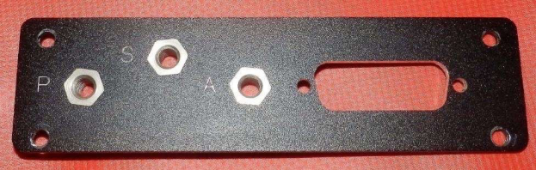*Figure 1 – Front Cover Face with PEM Nuts Installed.*

*Figure 2 – Front Cover Back with PEM Nuts Installed.*

_____ STEP 4 – Locate the Brass Low-Pressure Barbed Tube Fitting, Nickel-Plated, for 5/64" Tube ID x 10-32 Thread Male Pipe (P/N 2844K12) and install them on the PEM captive fasteners on the front face of the housing front plate in the locations AoA (“A”), Static (“S), and Pitot (“P”). Tighten the fitting by hand, then tighten with a wrench to approximately 12-inch pounds torque. There are O-Ring seals on these fittings so thread sealant should not be necessary.

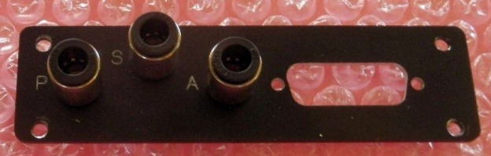

*Figure 3 – Front Panel with Tube Fittings Installed.*

_____ STEP 5 - Locate the barbed Tee fitting (P/N MCACS-1012-1132) and install it on the center 10-32 PEM fastener labeled “S” (Static). Position the lower part of the fitting with the two lateral ports with the ports to the sides. Tighten the fitting by hand, then tighten with a wrench to approximately 12-inch pounds torque.

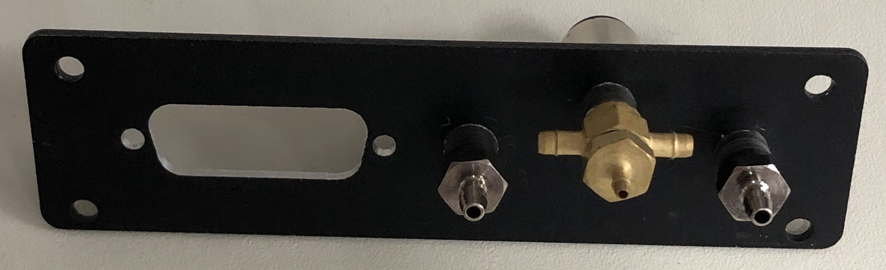*Figure 4 – Front Panel Back with Barbed Tube Fittings Installed.*

_____ STEP 6 – Locate the two (2) straight Brass Low-Pressure Barbed Tube Fittings, for 5/64" Tube ID x 10-32 Thread Male Pipe. Install one of the 10-32 PEM fasteners on the front plate in the location labeled “P” (Pitot) and the second on the PEM fastener labeled “A” (AoA). Tighten the fittings by hand, then tighten with a wrench to approximately 12- inch pounds torque.

_____ STEP 7 – Inspect printed circuit board for such things as rough edges, component holes that may be obstructed, misaligned solder mask, traces that are not fully plated or shorted together, etc.

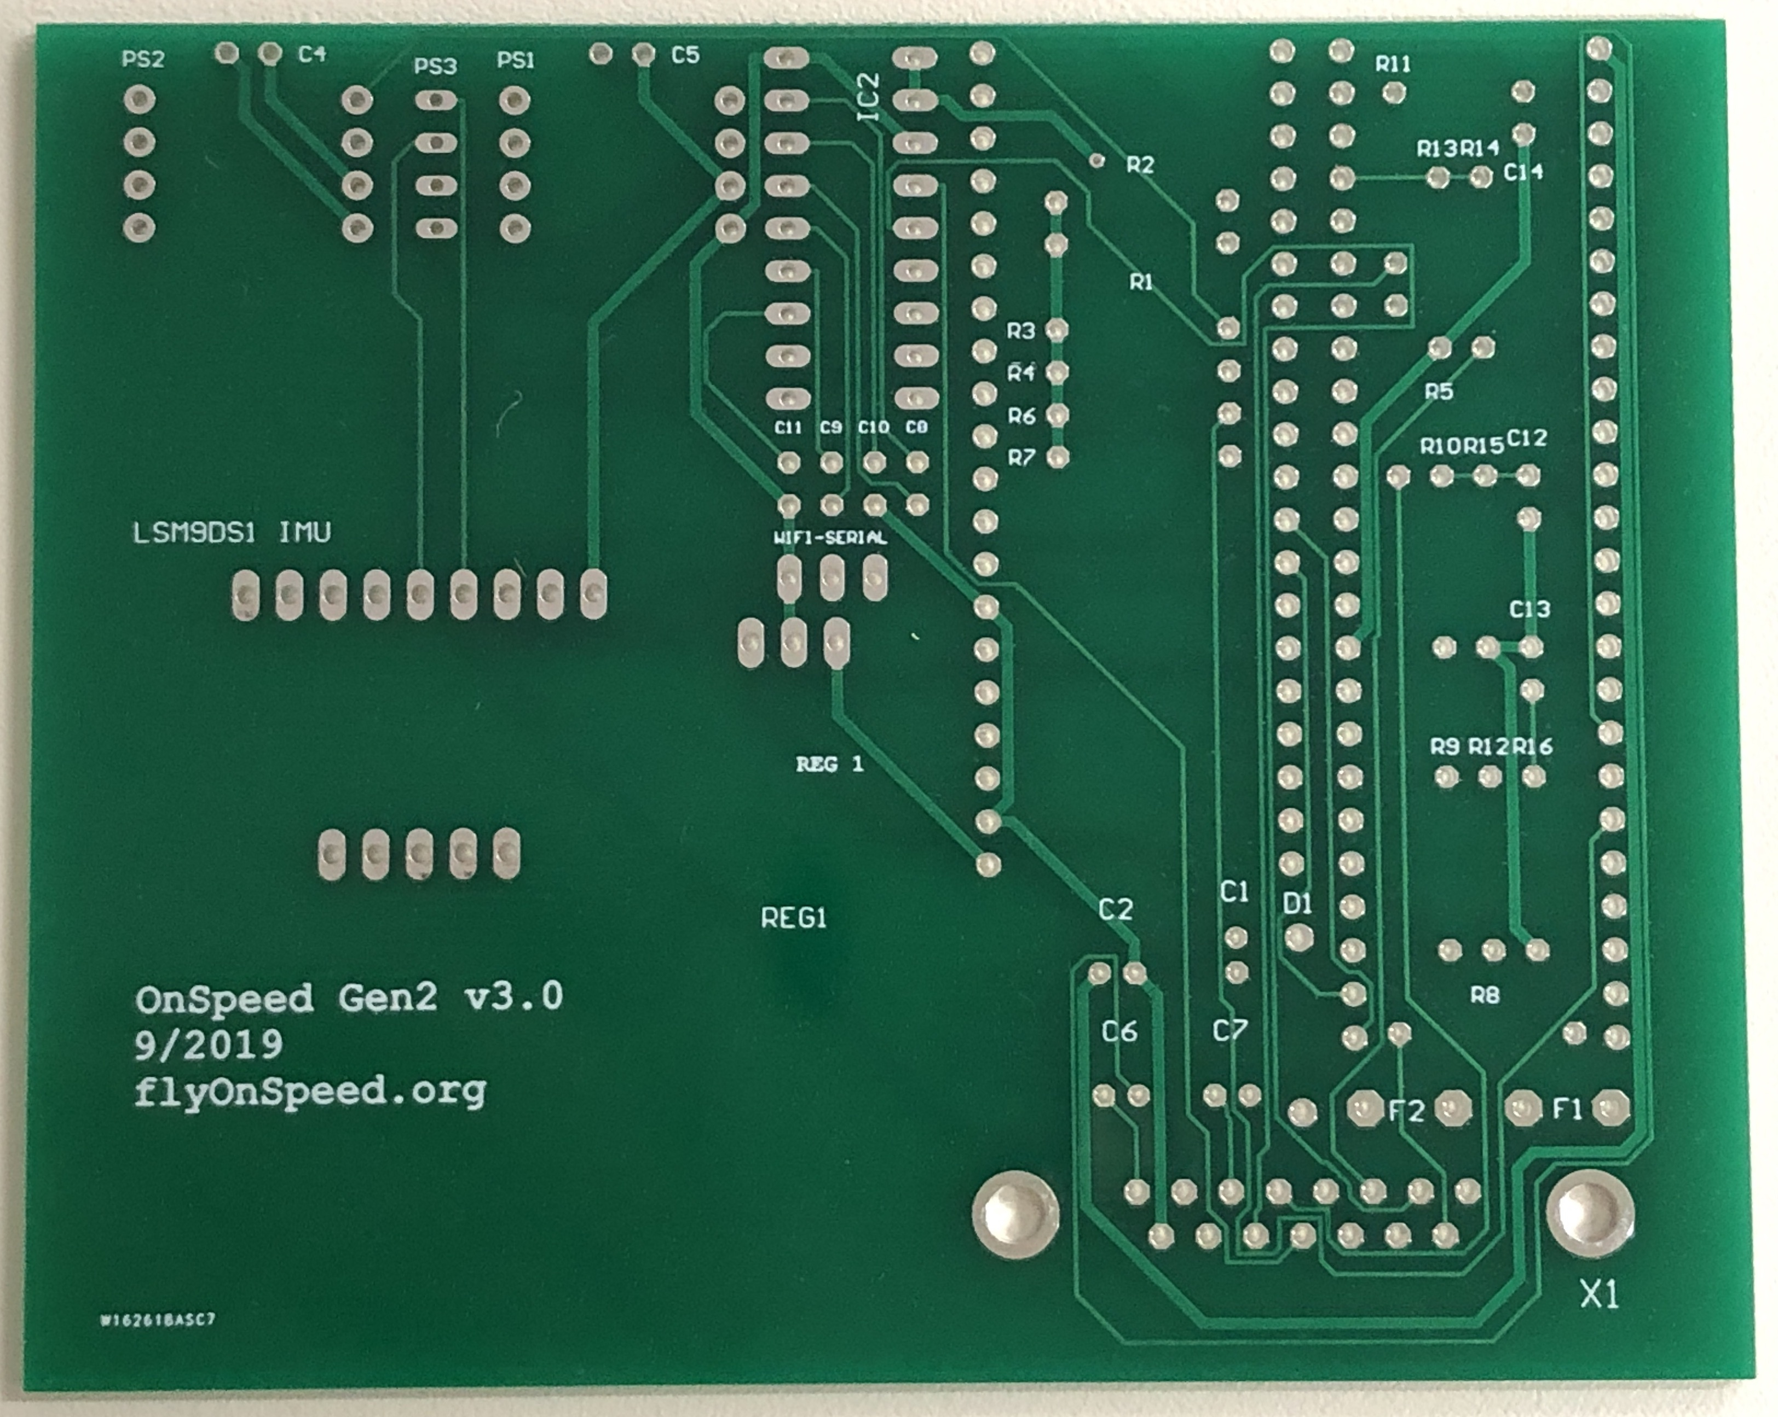*Figure 11 – PCB Top (component side)*

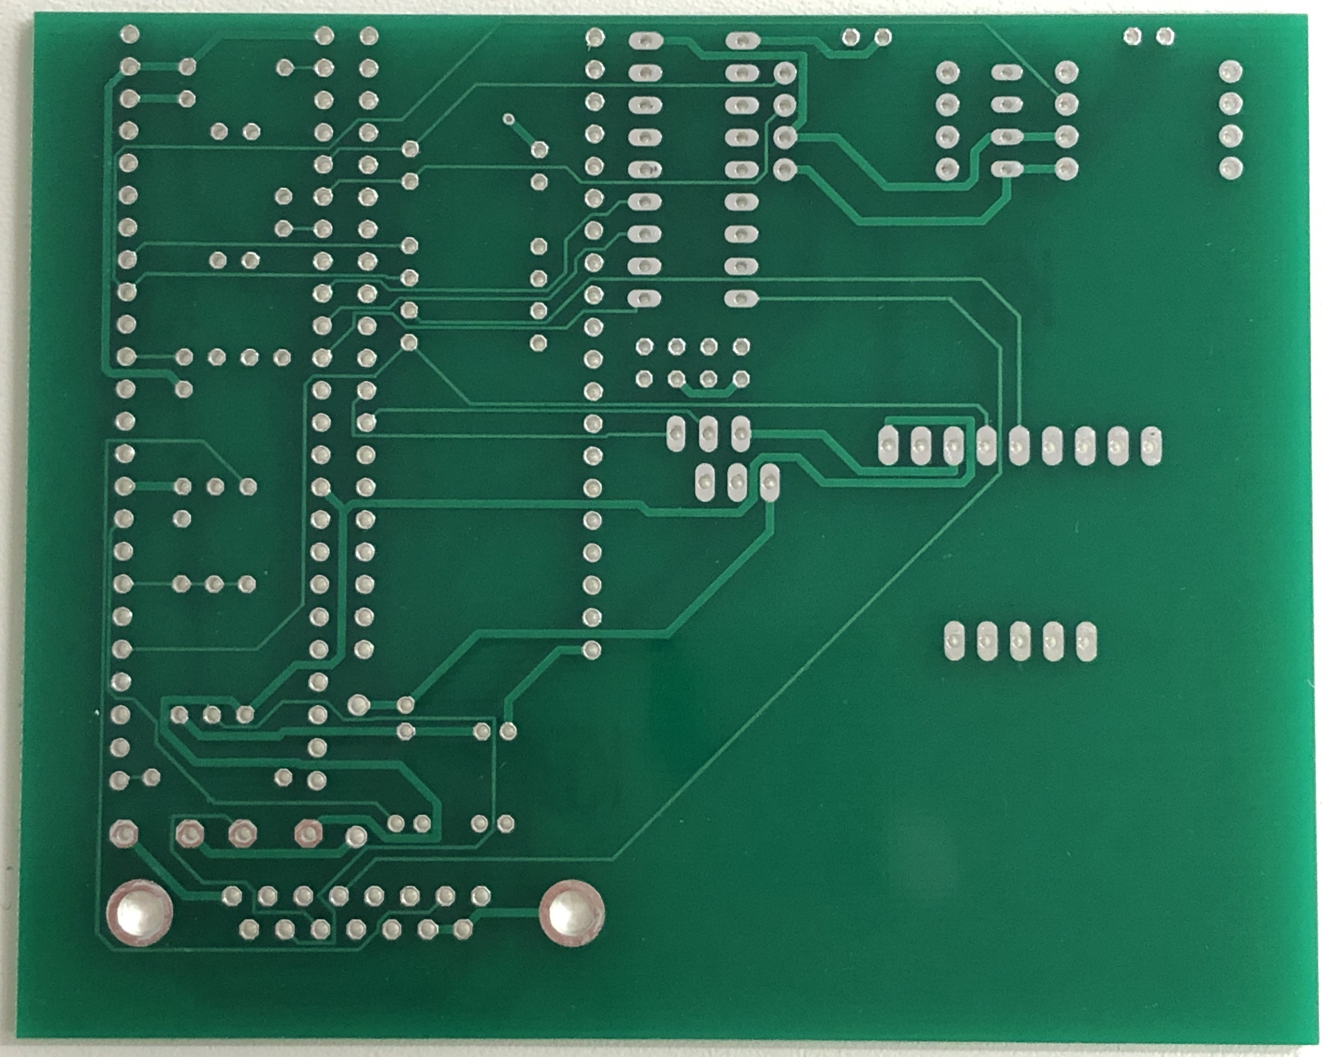*Figure 12 – PCB Bottom*

_____ STEP 8 - Clean PCB both sides with IPA and lint free cloth.

Parts list for PCB



Parts list for PCB (continued)



This image is used to Locate components on the PCB.

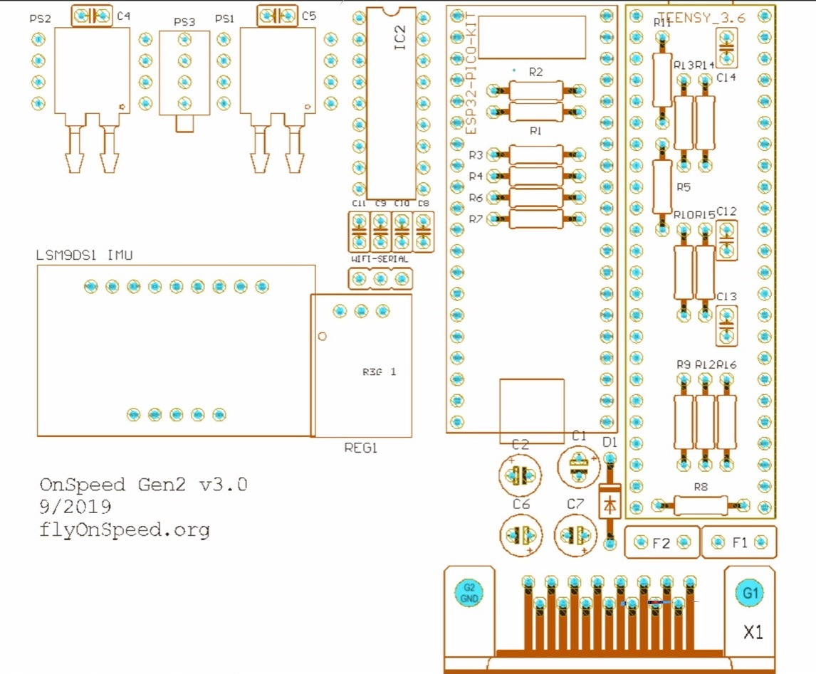

On Speed Gen 2 Version 3 Circuit Board Assembly

STEP 9 - Locate parts, bend, and insert the following resistors into the PCB:

_____ 1. R1 4.7K-ohm 5% Yellow – Violet – Red – Gold

_____ 2. R2 4.7K-ohm 5% Yellow – Violet – Red – Gold

_____ 3. R3 4.7K-ohm 5% Yellow – Violet – Red – Gold

_____ 4. R4 4.7K-ohm 5% Yellow – Violet – Red – Gold

_____ 5. R6 4.7K-ohm 5% Yellow – Violet – Red – Gold

_____ 6. R7 4.7K-ohm 5% Yellow – Violet – Red – Gold

_____ 7. Solder and clip.

STEP 10 - Locate parts, bend, and insert the following resistors into the PCB:

_____ 1. R5 150 Ohm 5% 1/2-W Brown – Green – Brown – Gold

_____ 2. R8 150 Ohm 5% 1/2-W Brown – Green – Brown – Gold

_____ 3. R11 150 Ohm 5% 1/2-W Brown – Green – Brown – Gold

_____ 4. R14 150 Ohm 5% 1/2-W Brown – Green – Brown – Gold

_____ 5. Solder and clip.

STEP 11 - Locate parts, bend, and insert the following resistors into the PCB:

_____ 1. R9 22K-ohm 5% Red – Red – Orange – Gold

_____ 2. R10 22K-ohm 5% Red – Red – Orange – Gold

_____ 3. R12 22K-ohm 5% Red – Red – Orange – Gold

_____ 4. Solder and clip.

STEP 12 - Locate parts, bend, and insert the following resistors into the PCB:

_____ 1. R13 20K-ohm 5% Red – Black – Orange – Gold

_____ 2. R15 5.6K-ohm 5% Green – Blue – Red – Gold

_____ 3. R16 5.6K-ohm 5% Green – Blue – Red – Gold

_____ 4. Solder and clip.

STEP 13 - Locate parts, bend, and insert the following resettable fuses into the PCB:

_____ 1. F1 60V 40 Amps Max Hold .50 Trip 1.00

_____ 2. F2 60V 40 Amps Max Hold .10 Trip .20

_____ 3. Solder and clip.

This image shows the correct location of the capacitors installed in the next several steps.

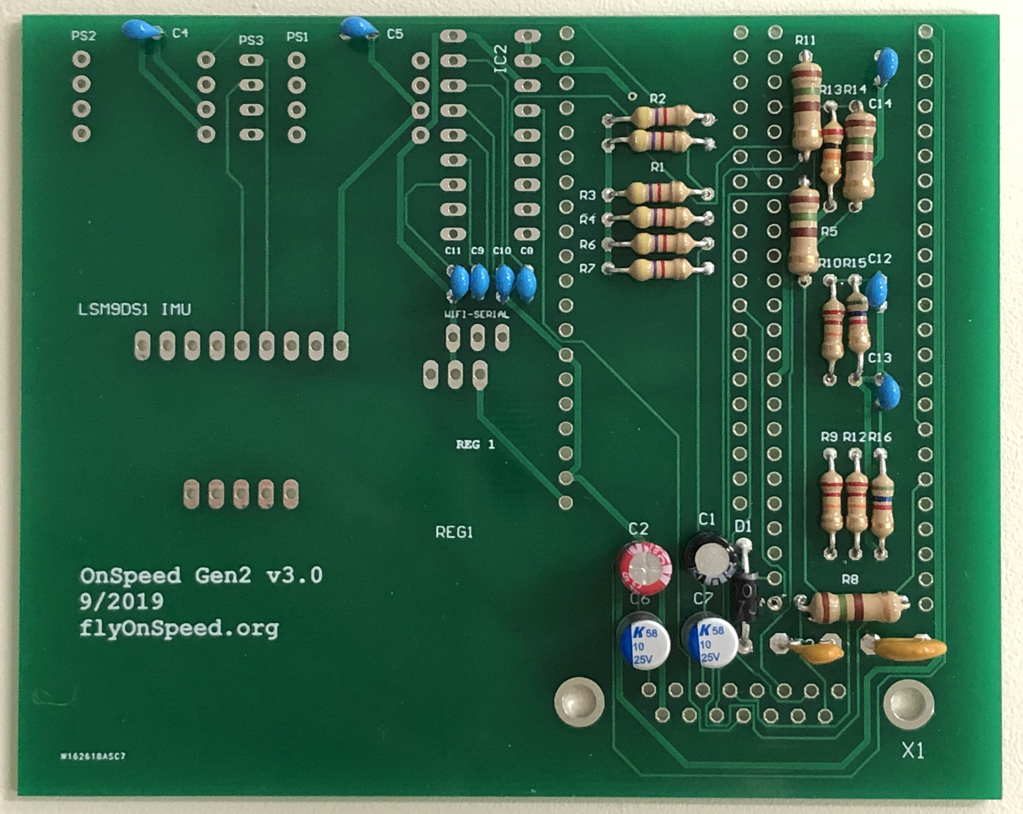

*Figure 13 – Capacitor Installation and Orientation*

STEP 15 - Locate part, bend, and insert the following Capacitor into the PCB:

_____ 1. C1 Aluminum Electrolytic Capacitor – Radial Leaded 10uF 50V

Observe polarity when installing this capacitor.

_____ 2. Solder and clip.

STEP 16 - Locate part, bend, and insert the following Capacitor into the PCB:

_____ 1. C2 Aluminum Electrolytic Capacitor – Radial Leaded WCAP-ATG5 0.1uF 50V 20% Radial

Observe polarity when installing this capacitor.

_____ 2. Solder and clip.

NOTE: C3 Not Used.

STEP 17 - Locate parts, bend, and insert the following Capacitors into the PCB:

_____ 1. C6 Aluminum Organic Polymer Capacitor 25V 10uF 20% ESR=70mOhms

Observe polarity when installing this capacitor.

_____ 2. C7 Aluminum Organic Polymer Capacitor 25V 10uF 20% ESR=70mOhms

Observe polarity when installing this capacitor.

_____ 3. Solder and clip.

STEP 18 - Locate parts, bend, and insert the following Capacitors into the PCB:

_____ 1. C4 Multilayer Ceramic Capacitor MLCC – Leaded 0.1uF 25V X7R 10%

_____ 2. C5 Multilayer Ceramic Capacitor MLCC – Leaded 0.1uF 25V X7R 10%

_____ 3. C8 Multilayer Ceramic Capacitor MLCC – Leaded 0.1uF 25V X7R 10%

_____ 4. C9 Multilayer Ceramic Capacitor MLCC – Leaded 0.1uF 25V X7R 10%

_____ 5. C10 Multilayer Ceramic Capacitor MLCC – Leaded 0.1uF 25V X7R 10%

_____ 6. C11 Multilayer Ceramic Capacitor MLCC – Leaded 0.1uF 25V X7R 10%

_____ 7. C12 Multilayer Ceramic Capacitor MLCC – Leaded 0.1uF 25V X7R 10%

_____ 8. C13 Multilayer Ceramic Capacitor MLCC – Leaded 0.1uF 25V X7R 10%

_____ 9. C14 Multilayer Ceramic Capacitor MLCC – Leaded 0.1uF 25V X7R 10%

_____ 10. Solder and clip.

STEP 19 - Locate part, bend, and insert the following Diode into the PCB:

_____ 1. D1 Rectifier Vr/50V lo/1A

_____ 2. Solder and clip.

This image shows the correct Orientation of the diode.

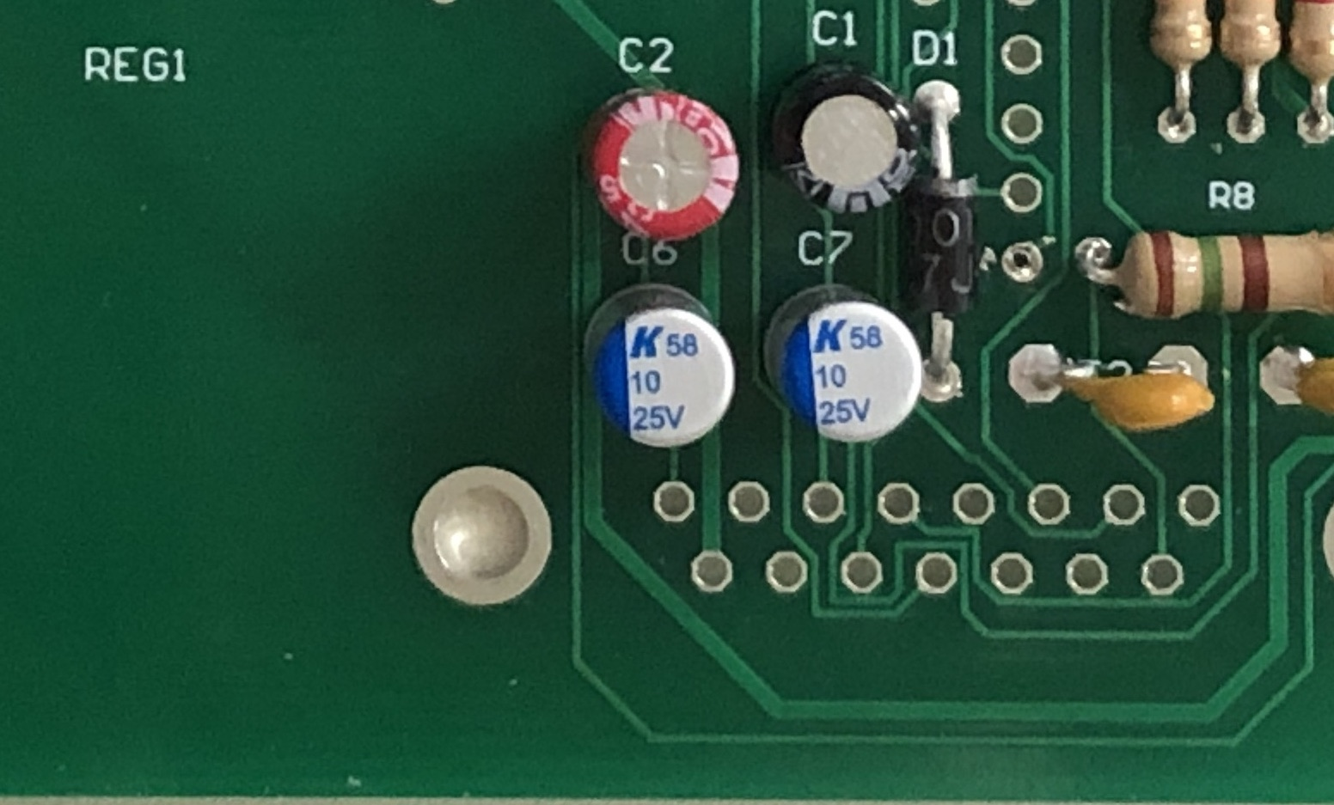

Figure 14 – Diode D1 Installation and Orientation

STEP 20 - Locate parts and insert the following parts into the PCB. Use paper tape to hold in position:

_____ 1. WiFiSerial Header 1X3 POS VERT Tin

_____ 2. (2) WIFI SOCKETS 3M 20 CON

_____ 3. (2) TEENSSY SOCKETS 3M 24P STRK BRD MNT SKT

_____ 4. Solder one (1) pin of each connector to circuit board.

_____ 5. Inspect each connector above to verify that they are vertical out of the PCB. Heat and reflow solder if necessary to get vertical.

_____ 6. Solder remaining leads of above connectors.

Verify that connectors are vertical before moving on to next step.

STEP 21 - Locate part and insert into PCB:

_____ 1. SUB-D DSUB SV FEM SSDP Connector

_____ Solder to circuit board.

STEP 22 - Locate part and insert into the PCB:

_____ 1. REG1 Voltage regulator P/N OKI-78SR-5/1 .5-W36H-C)

Note: It may be necessary to use paper tape to hold REG1 in place before PCB is turned over to solder. Solder one pin and check before soldering all pins.

_____ 2. Solder to circuit board.

_____ 3. Trim the excess pin lengths and inspect.

STEP 23 - Locate part IMU1 and open in static safe location.

_____ 1. Cut supplied 0.100-inch pitch headers into nine (9) pins and a second length with five (5) pins.

_____ 2. Insert headers into IMU1 holes on the PCB then position the IMU board over the header pins. Make sure the IMU1 board is fully seated on the headers and parallel with the PCB.

_____ 3. Solder all 28 pins (14 on the PCB and 14 on the breakout board)

_____ 4. Trim the excess pin lengths and inspect.

STEP 24 - Locate IC2 and open in static safe location.

_____ 1. Bend pins so IC2 will fit into PCB.

_____ 2. Insert IC2 into PCB. Notch in IC2 is located near edge of PCB.

_____ 3. Solder IC2 to PCB.

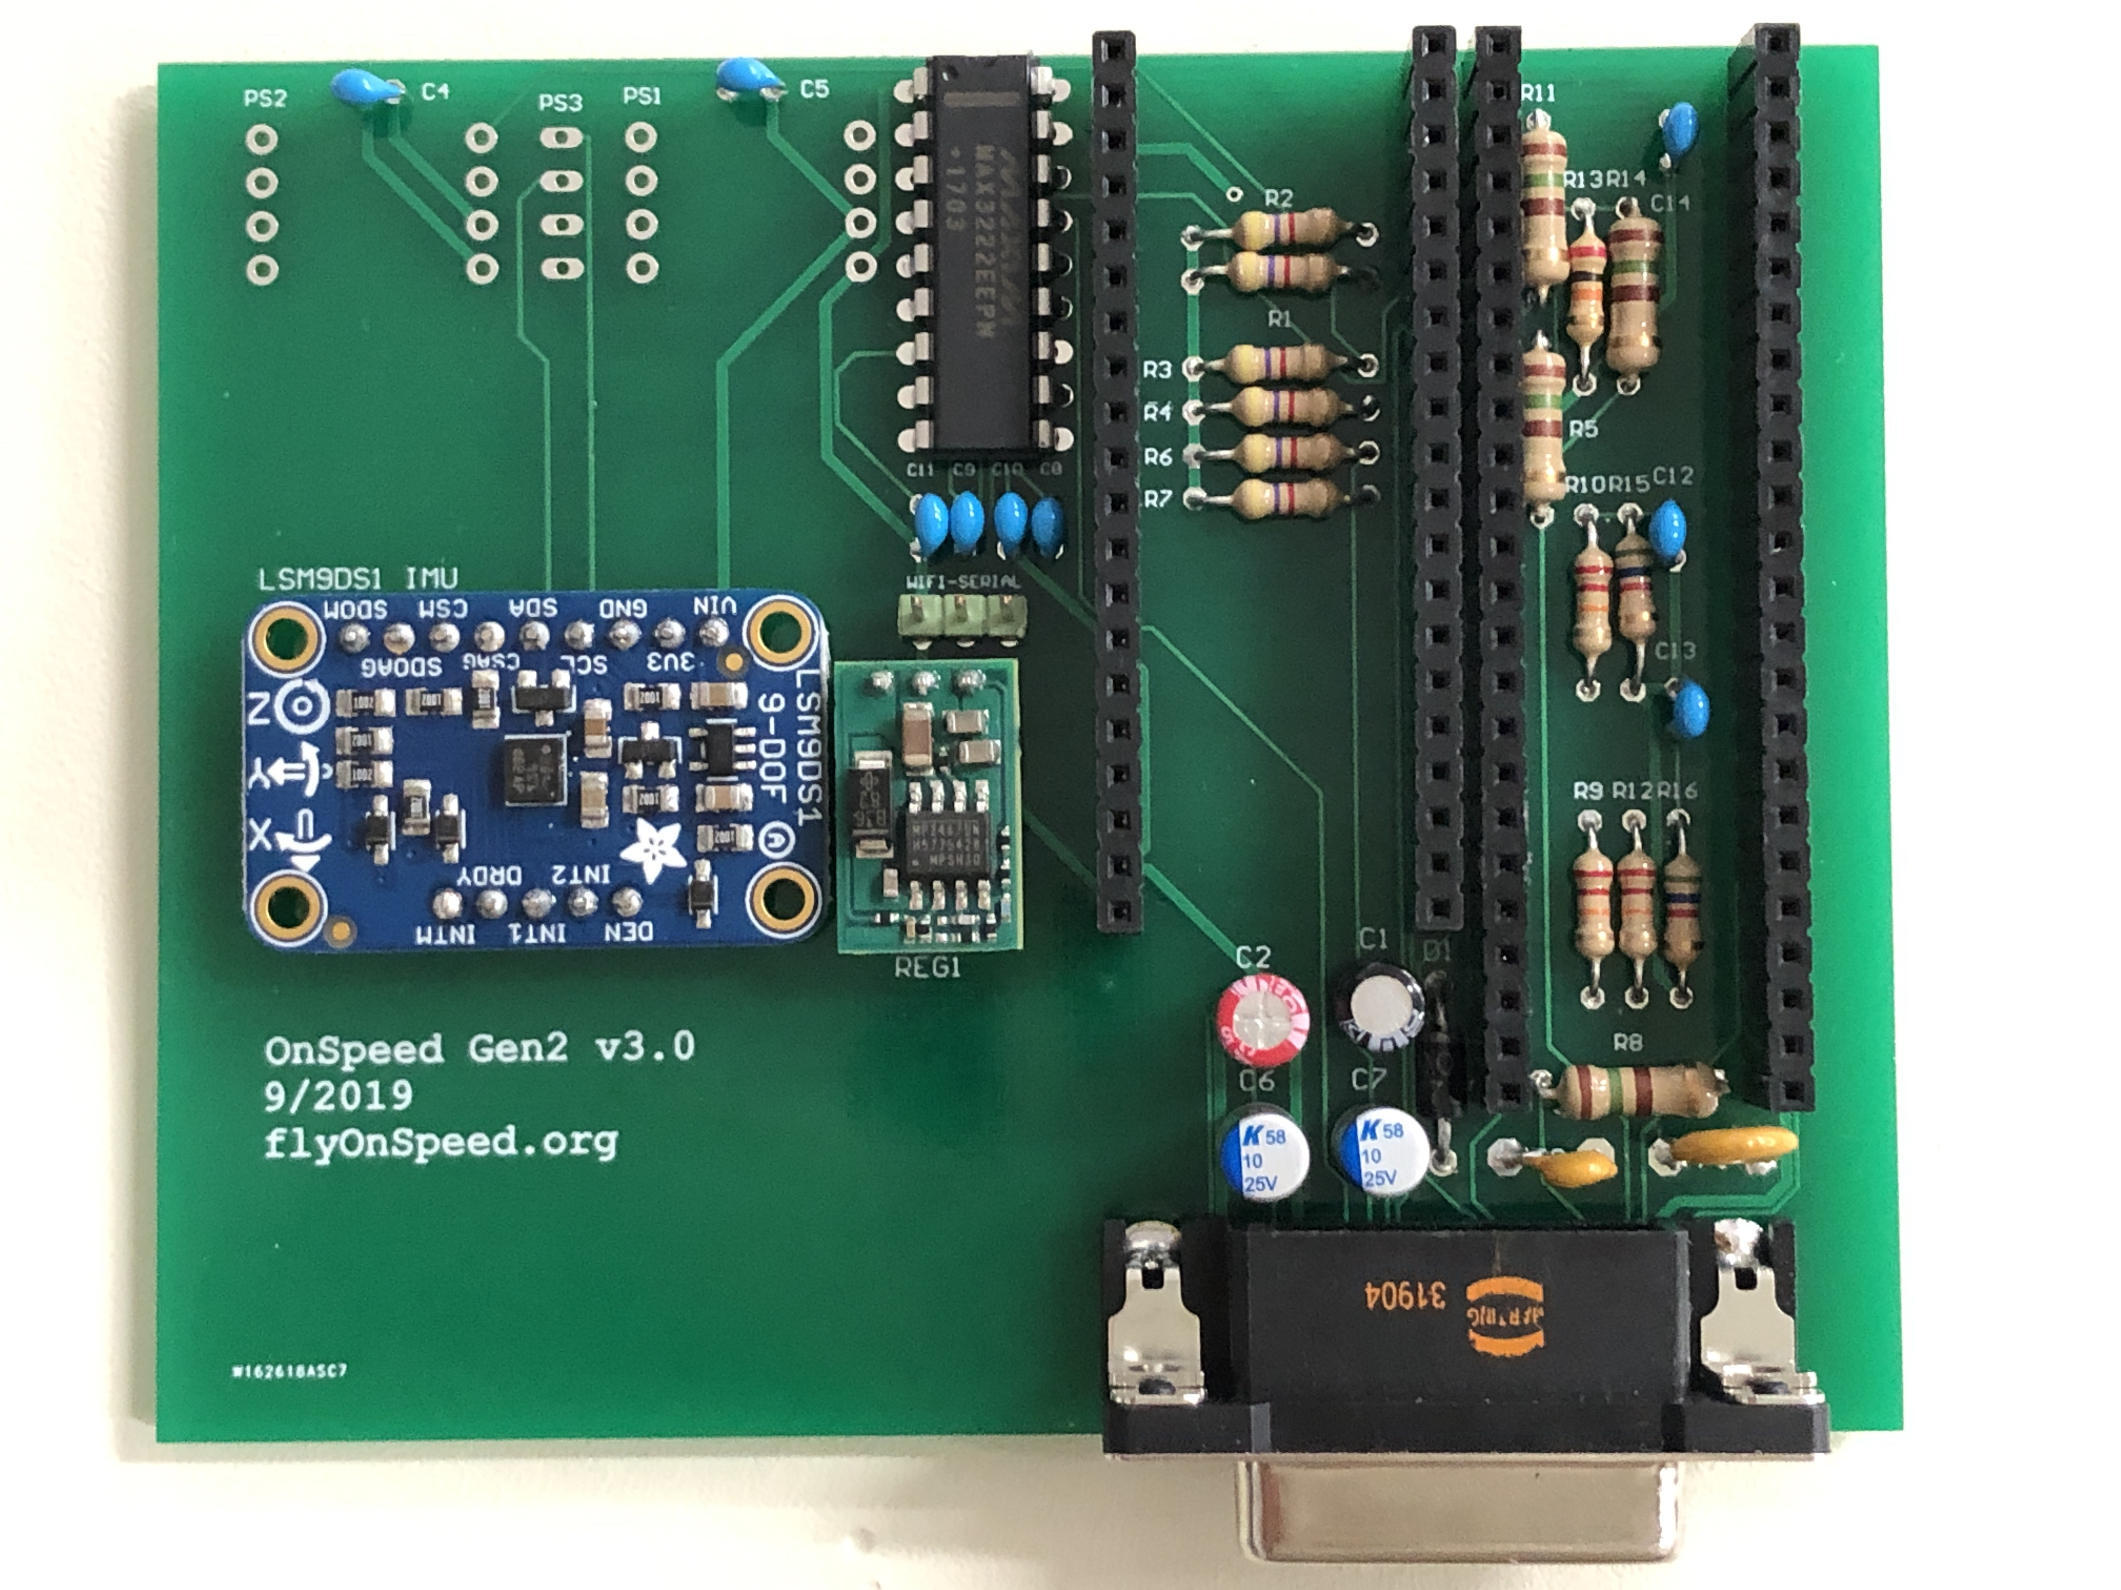PCB with REG1 and IMU soldered in place.

STEP 25 - Locate the 3/32-inch ID, 5/32-inch OD Polyurethane Tubing (P/N 5648K68) and cut four (4) lengths of tubing as follows:

_____ a. 2 each – 2.25 inches long (PS1 Lower Port to AoA fitting connection, PS2 Lower Port to Pitot fitting connection).

_____ b. 2 each – 2.75 inches long (PS1 Upper Port to Static Tee fitting connection, PS2 Upper Port to Static Tee fitting connection).

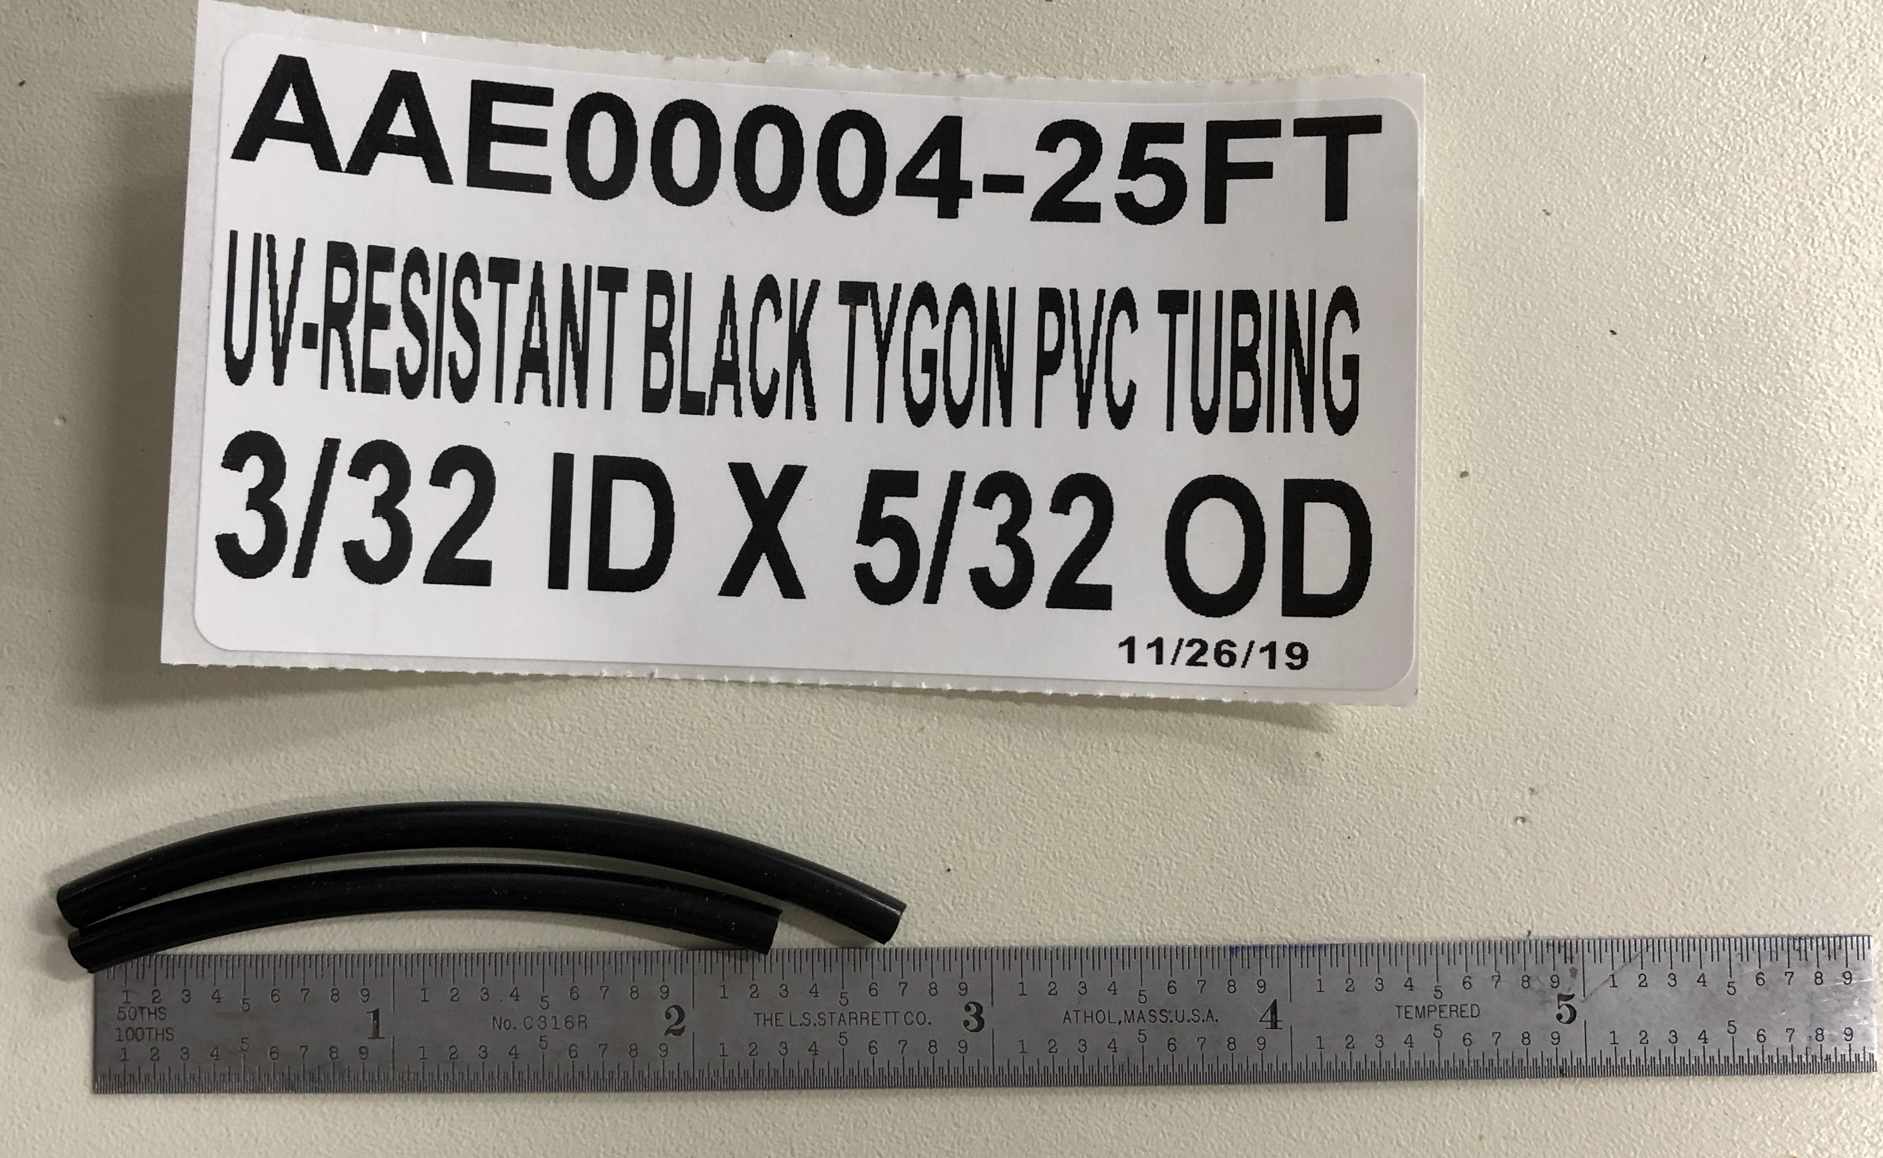

STEP 26 – Locate the 1/16-inch ID, 1/8-inch OD Polyurethane Tubing (P/N 5648K67) and cut one (1) length of tubing as follows:

_____ a) 1 each – 2.0 inches long (PS3 Static sensor to Static Port Tee)

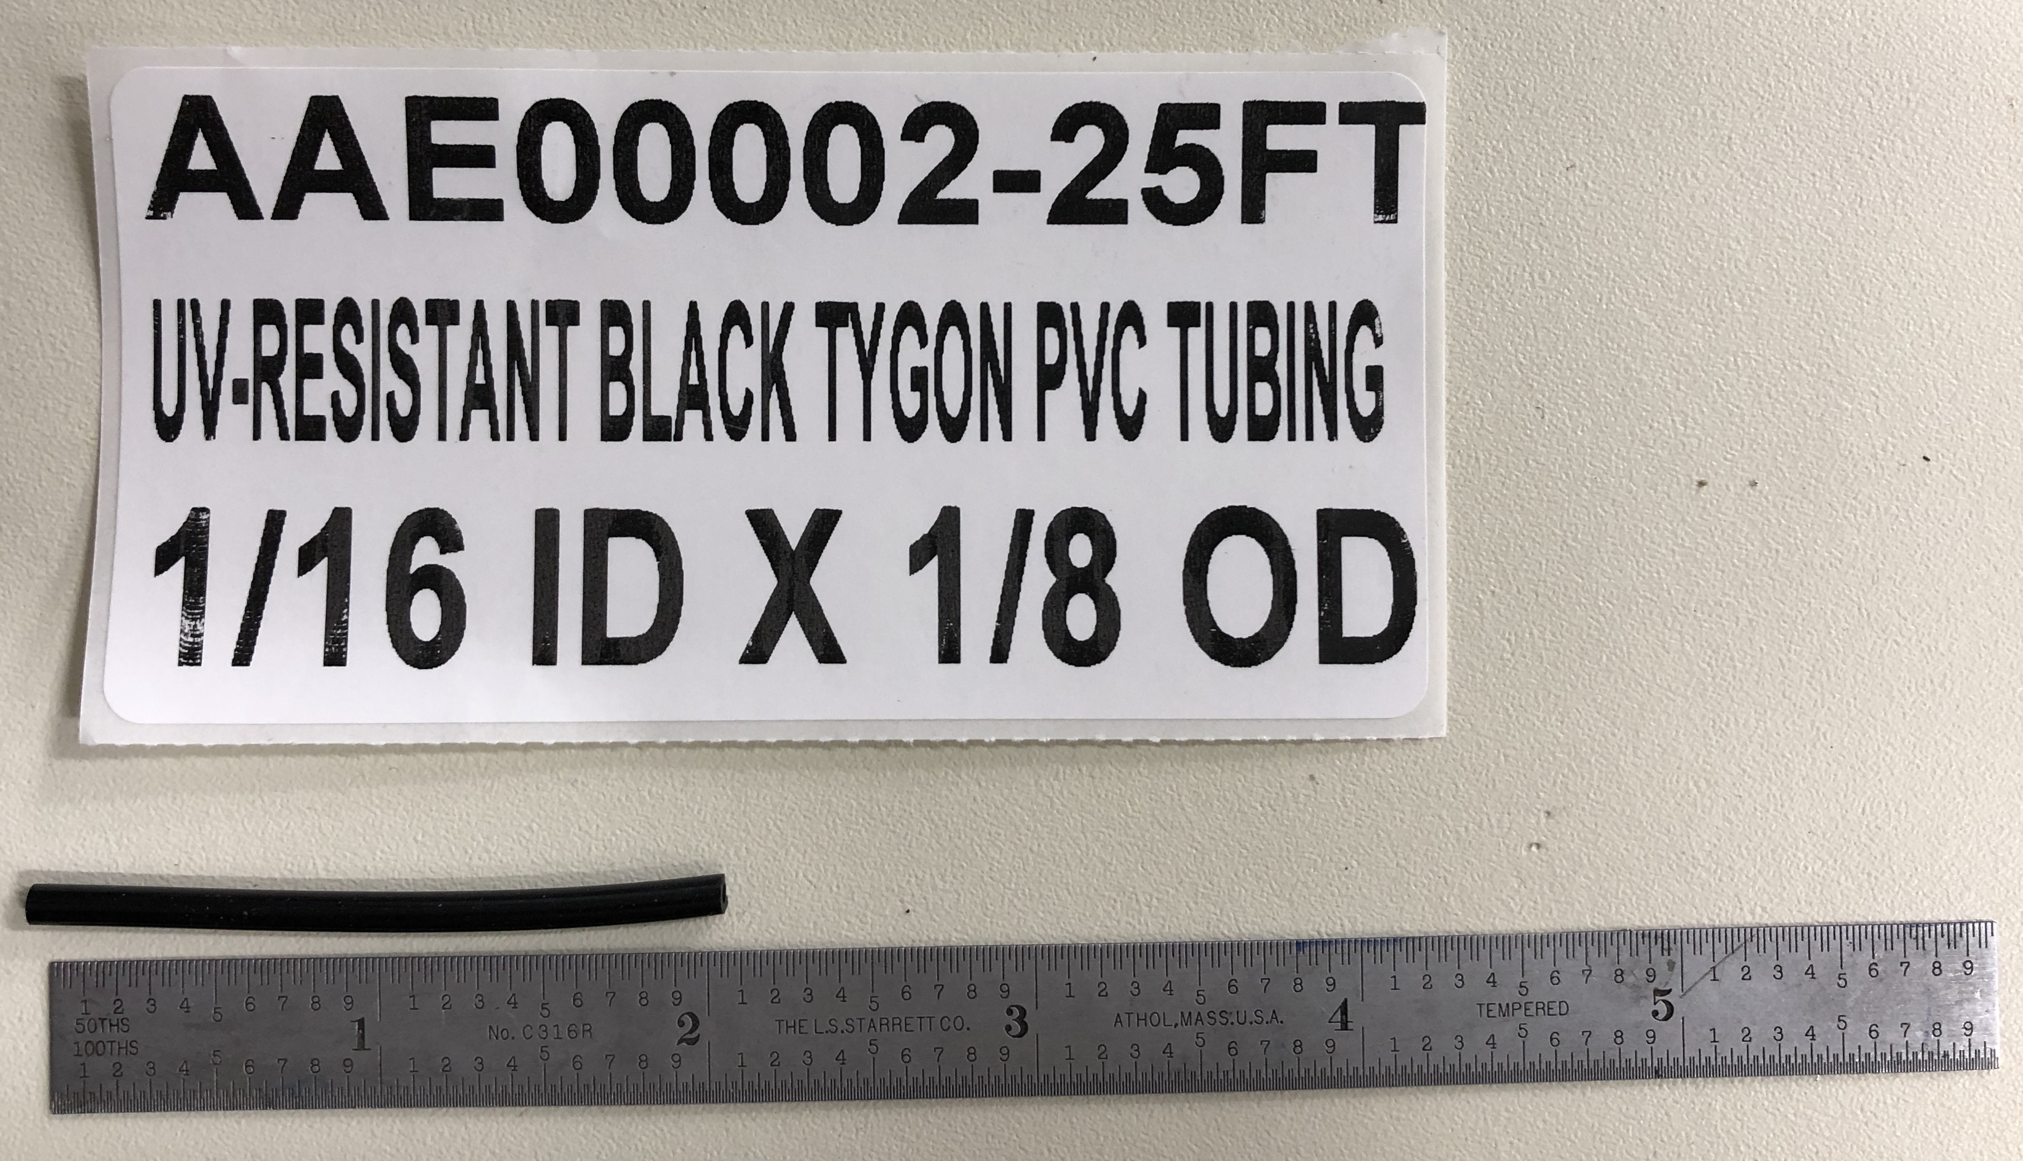

_____ STEP 27 - Locate the two dual port pressure sensors (P/N 4525DO-DS5AI001DP). Using an indelible ink pen mark one “PS1” and the second “PS2”. Note that when viewed from the top, pins down, the sensors have two barbed ports. The lower port (PORT 1) and an upper port (PORT 2). It is important that the ports are connected to the correct aircraft pneumatic fittings during assembly. Note also that the plastic barbs on the sensors are relatively easy to break off the sensors so care must be taken to limit the angular force that is applied to the barbs during

the installation of the polyurethane tubing.

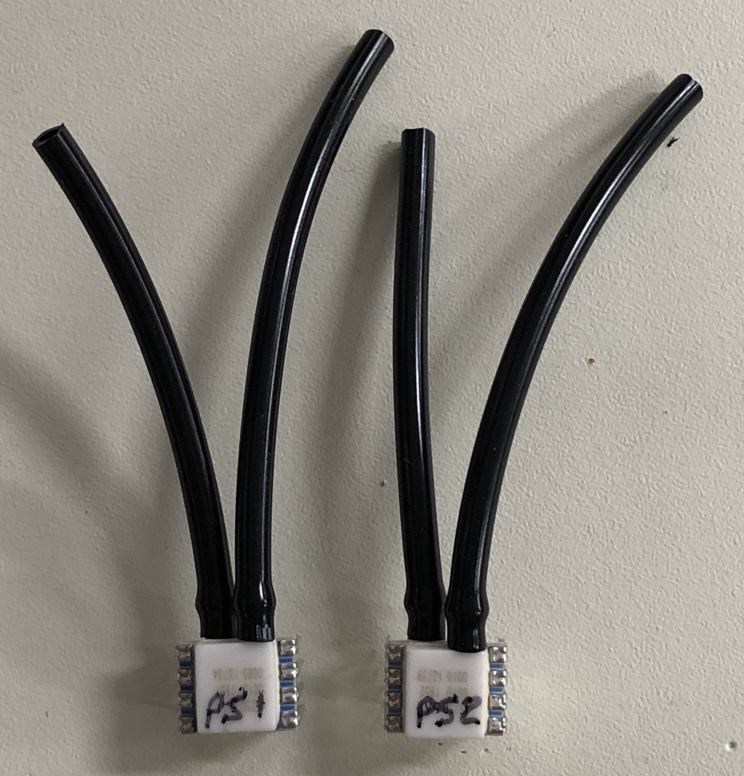

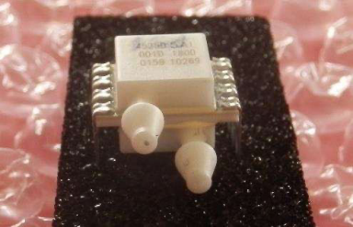

STEP 28 - Install the four pieces of 3/32 inch ID tubing cut to length in STEP 25 on the dual port pressure sensors (PS1 and PS2). NOTE: the polyurethane tubing used in the following steps has a relatively high Durometer of 95A at room temperatures and is therefore rather inflexible. In order to slip the tubing onto the barbed fitting it is sometimes useful to warm the tubing ends in hot water just prior to sliding the tubing over the barbed connections (shake off the excess water so that it does not enter the sensor ports).

The 3/32-inch tubing will be installed on the dual port pressure sensors as follows:

_____ a) Install one of the 2.25-inch lengths on PS1 LOWER PORT 1.

_____ b) Install one of the 2.75-inch lengths on PS1 UPPER PORT 2.

_____ c) Install one of the 2.75-inch lengths on PS2 UPPER PORT 1.

_____ d) Install one of the 2.25-inch lengths on PS2 LOWER PORT 2.

STEP 29 - Install the piece of 1/16 in ID tubing cut to length in STEP 25 on the single port pressure sensor PS3 (P/N SSCSRNN1.6BA7A3) as follows:

a) Install the 2.0-inch lengths of 1/16 inch ID tubing on PS3.

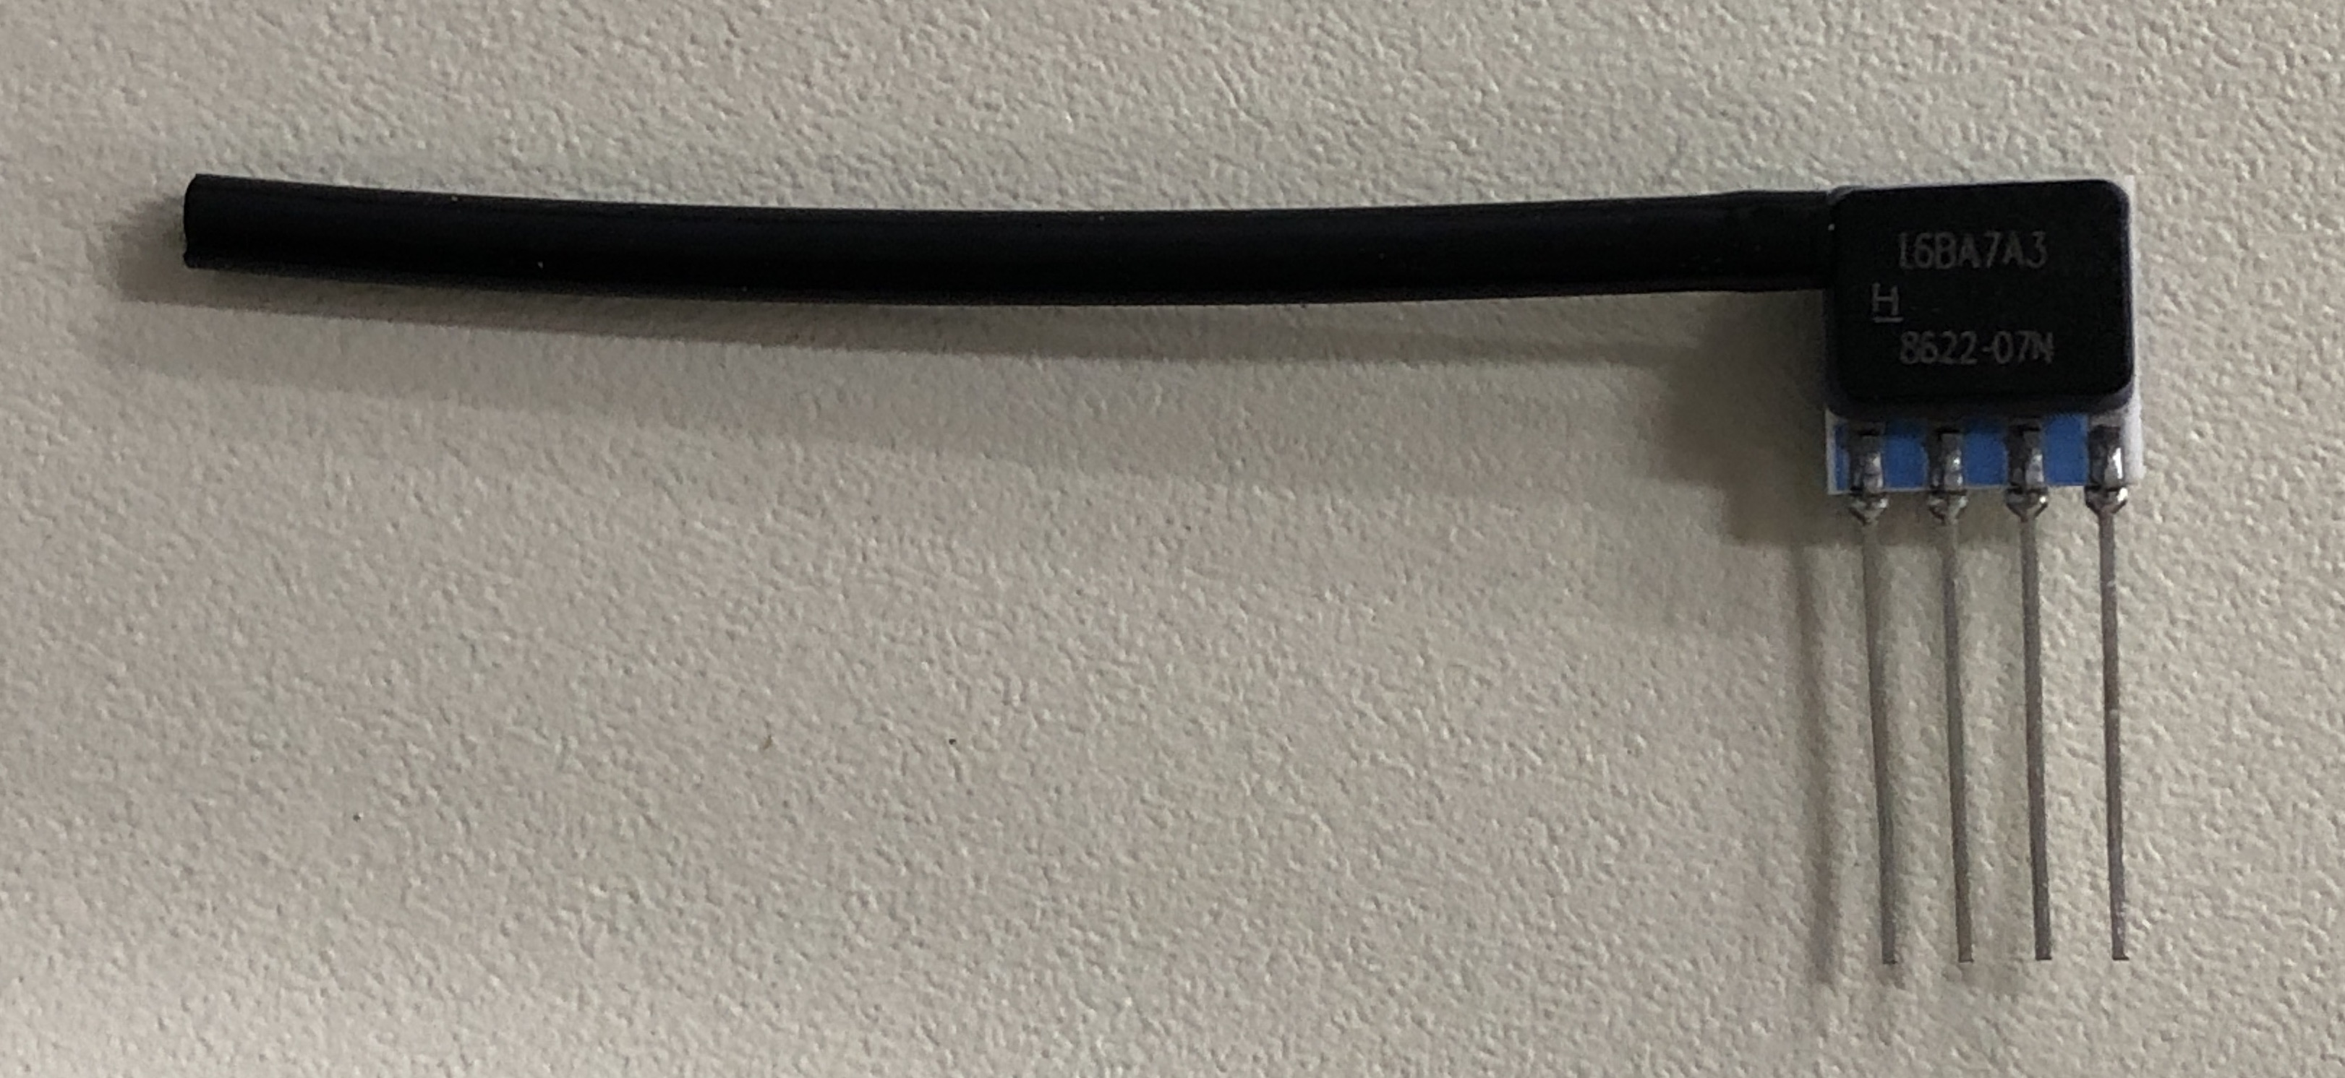

STEP 30 - Locate PS1 with its installed tubing and insert into the PCB:

_____ 1. Solder one of the 8 pins to the PCB. Verify that PS1 is properly positioned on the PCB.

_____ 2. Solder PS1 to PCB and inspect.

STEP 31 - Locate PS2 with its installed tubing and insert into the PCB:

_____ 1. Solder one of the 8 pins to the PCB. Verify that PS2 is properly positioned on the PCB.

_____ 2. Solder PS2 to PCB and inspect.

STEP 32 - Locate PS3 with its installed tubing and insert into the PCB:

_____ 1. Solder one of the 4 pins to the PCB. Verify that PS3 is properly positioned on the PCB.

_____ 2. Solder PS3 to PCB, trim excess leads, and inspect.

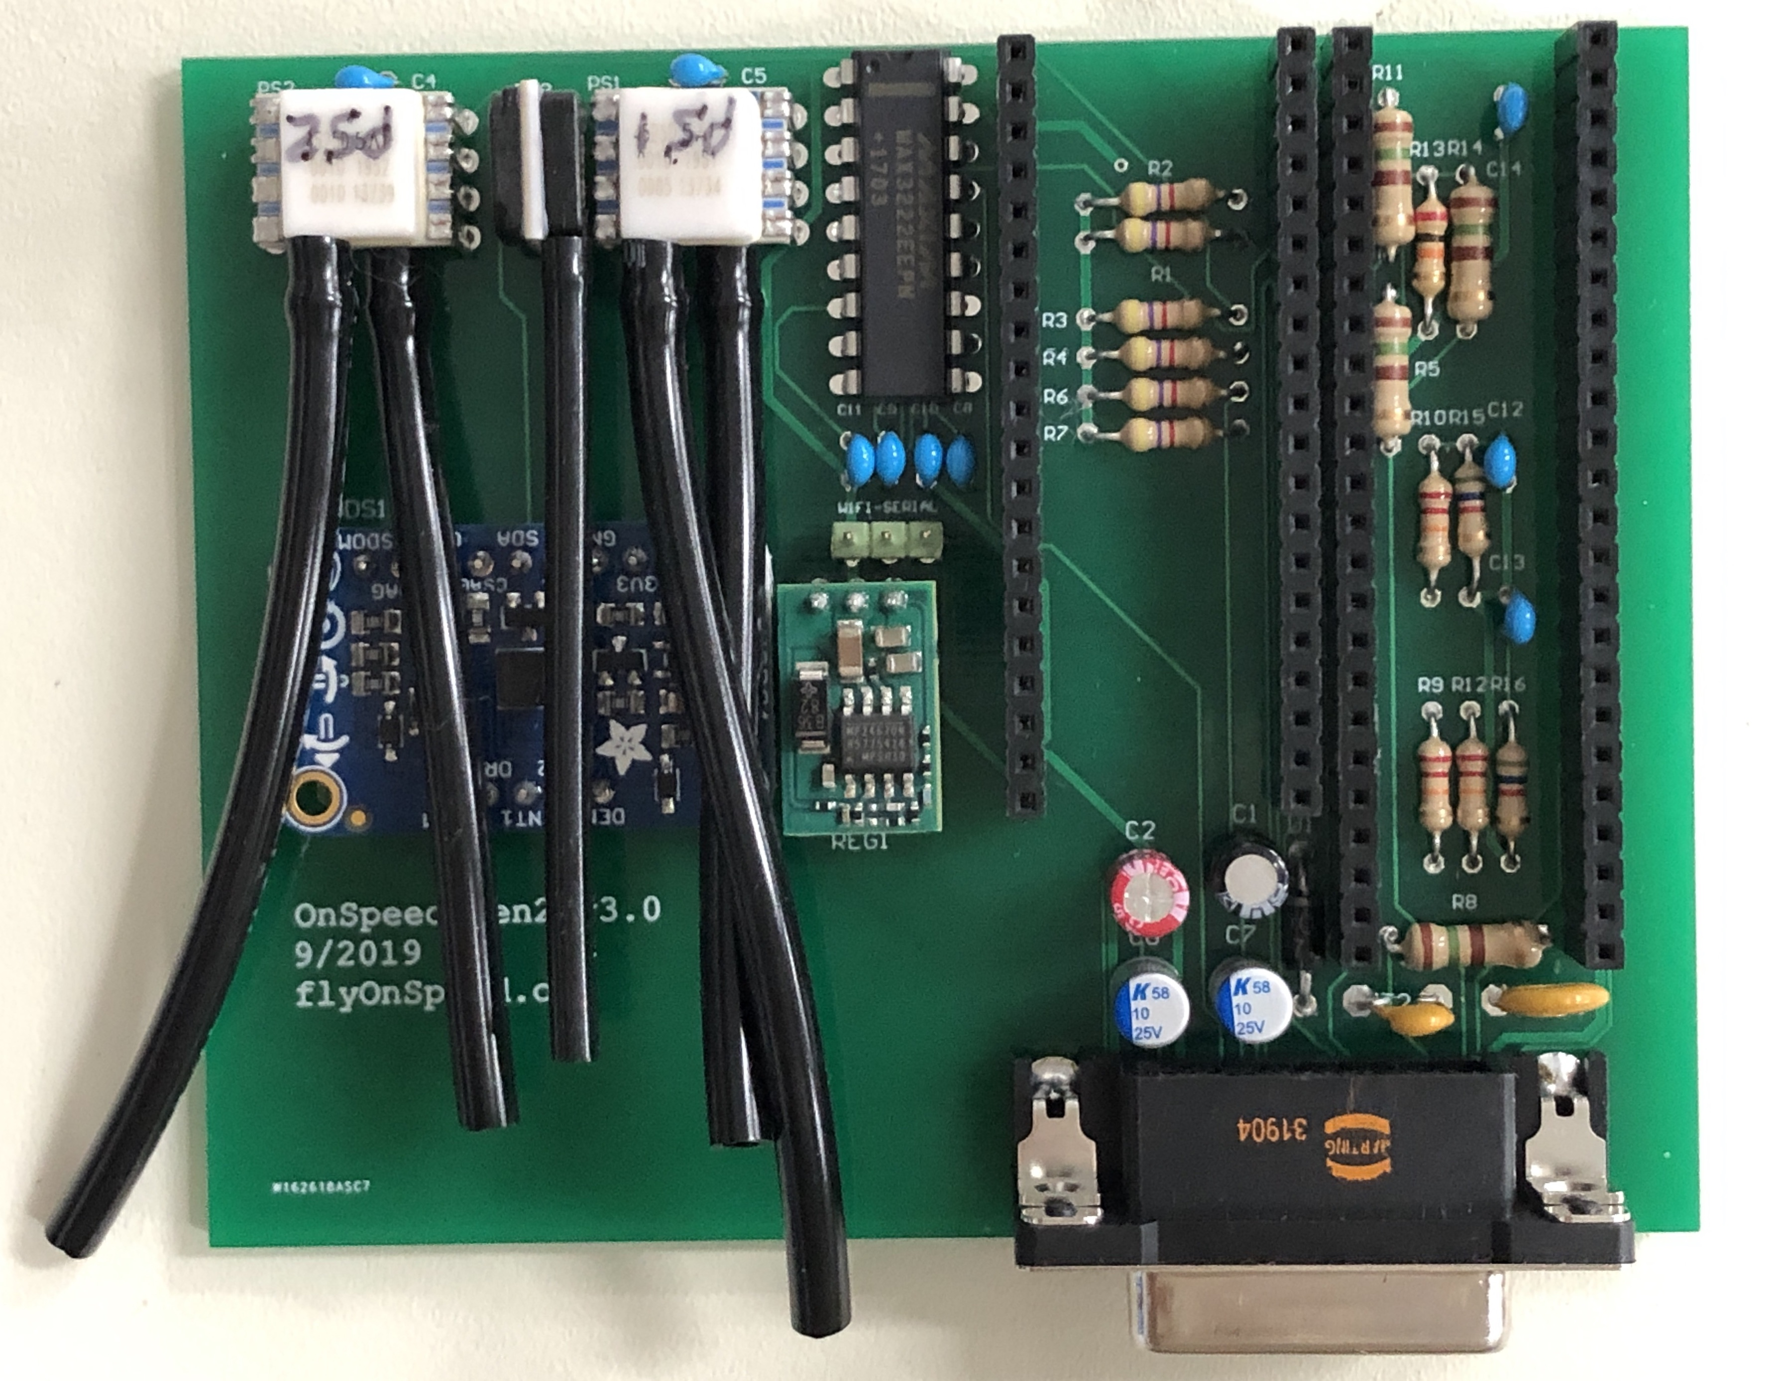PCB with pressure sensors solder in place.

STEP 33 - Locate front panel.

Install front panel on the D-Sub 15 contact connector that was installed on the CCA using two (2) of the

_____ 4-40 Female Jackscrew (P/N 160-000-015R031). Apply a small amount of thread locking liquid to the threaded screws. (Loctite blue or equivalent). Tighten the standoffs in the D-Sub Connector.

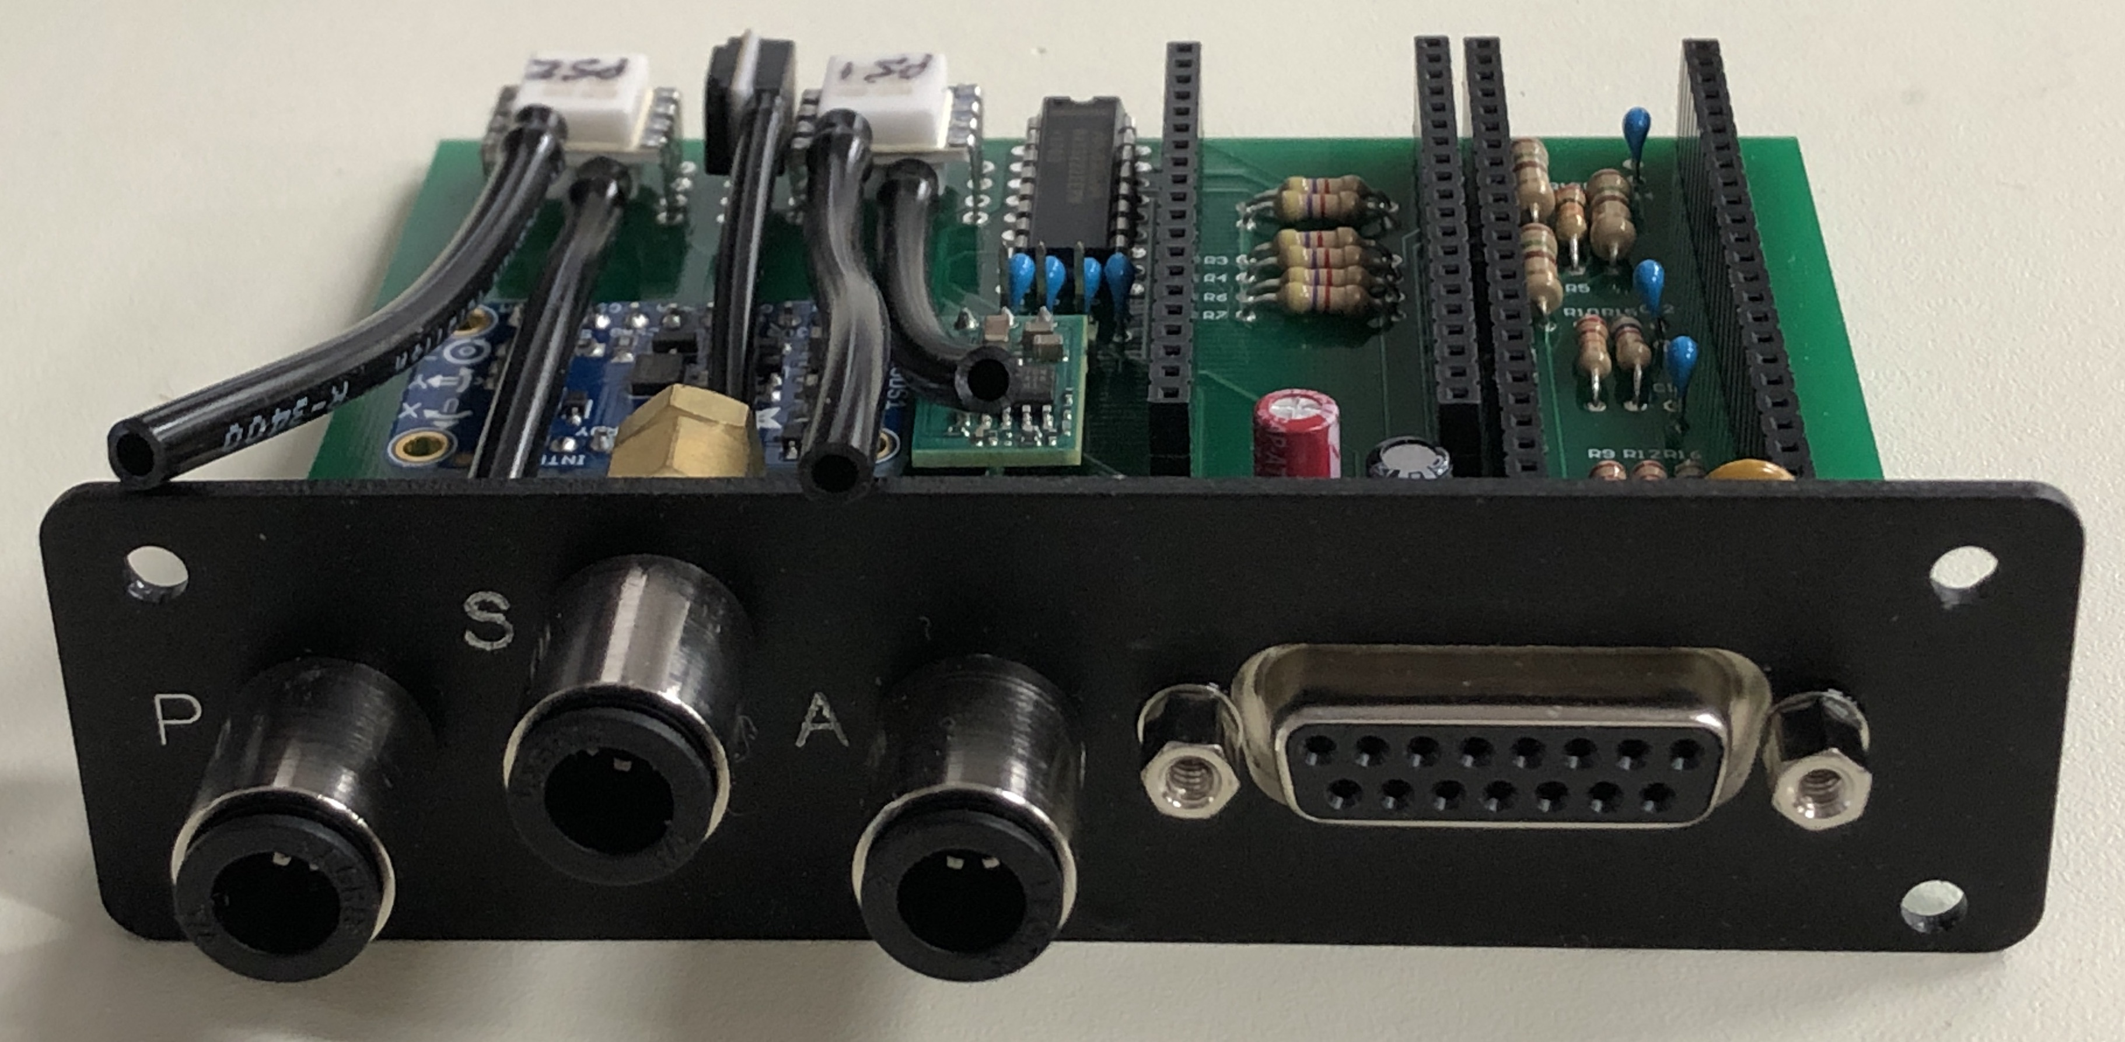

*Figure 21 – Front Panel Installed on CCA*

STEP 34 - Connect the pressure sensor tubing to the front panel pneumatic fittings as follows:

_____ a) Connect the tube on PS1 LOWER PORT 1 to the AoA (“A”) fitting.

_____ b) Connect the tube on PS1 UPPER PORT 2 to the Static (“S”) Tee barb nearest to the “A” fitting.

_____ c) Connect the tube on PS3 to the center barb on the “S” Tee.

_____ d) Connect the tube on PS2 LOWER PORT 1 to the “P” fitting.

_____ e) Connect the tube on PS2 UPPER PORT 2 to the Static “S” Tee barb nearest to the Pitot (“P”) fitting.

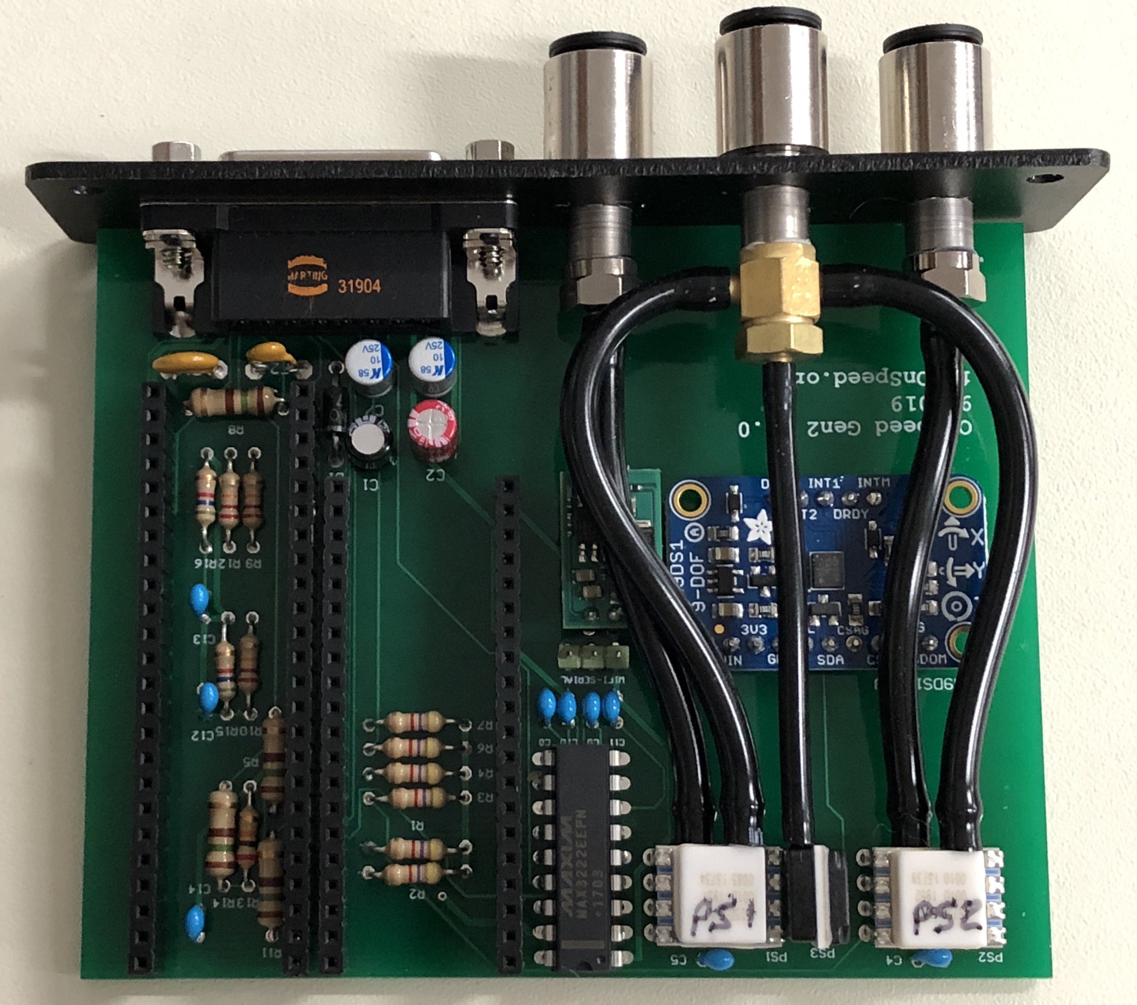

*Figure 10 – Front Panel with Pressure Sensors Installed*

_____ STEP 35 - Inspect completed front panel subassembly.

_____ STEP 36 - The ESP32 WiFi Development Tool (802.11) ESP32-PICO-D4 Development Board must be programmed off of the OnSpeed Gen 2 V3 PCB. It is recommended to use the Programming Procedure document to program it before installing it on the OnSpeed Gen2 V3 PCB. After programming, inset the board into its sockets with the antenna end near the end of the board that the pressure sensors are located. Note that there are six (6) pins on that end of the board that are not used. Check this step off once the board is programmed and installed.

_____ STEP 37 - Remove the Teensy chip from its static safe container in a static safe area and insert the microSD card into the Teensy microSD slot.

_____ STEP 38 - Insert the Teensy board into its socket on the OnSpeed Gen 2 V3 PCB with the microSD card installed. The microUSB connector is at the same end of the PCB that the pressure sensors are located.

_____ STEP 39 - Program the Teensy in accordance with procedures in the programming manual. Check this step off once programmed and initial testing has been completed.

_____ STEP 40 – In order to reduce the potential for bending the pins under handling, vibration, and shock it is recommended that small amount of adhesive (Eclectic Products Inc. E6000 or equivalent) be applied to the base of the Static Pressure sensor (PS3), the DC to DC converter (REG1), and the PCB in order to dampen potential motion if the part relative to the pins. It may be necessary to preform the step again after some cure time as the E6000 is thin and can run while curing. (E6000 can be purchased at your local Walmart in either Home Improvement or Craft section.)

_____ STEP 41 – Inspect the sub assembly for missing or misaligned components, improperly inserted component pins, solder quality and workmanship, etc. It is recommended to clean the flux off the solder side of the PCB with IPA. Lacquer Thinner has been know to be used when the flux is difficult to remove..

_____ STEP 42 – Insert the subassembly into the housing and secure it in place using the screws provided with the housing. NOTE: The housing screw bosses are offset. The housing has a ribbed face which should be oriented down relative to the front panel on order for the screw holes to align.

_____ STEP 43 – Install the plastic (RF transparent) rear cover using the screws provided.

The following steps will need to be performed prior to the final acceptance of the system in the aircraft. These procedures are supplied as separate documents on the OnSpeed website.

_____ STEP 44 – Leak test the pneumatic connections.

_____ STEP 45 – Connect the wiring harness and bench test the OnSpeed controller. The OnSpeed electronics assembly should be functionally bench tested prior to installation into the aircraft.

_____ STEP 46 – Install the OnSpeed 2 system in the aircraft.

_____ STEP 47 – Flight test and calibrate the OnSpeed 2 system.

**CONCLUSION**

Hopefully this document has provided the information necessary to assemble the OnSpeed Generation 2 electronics assembly. As we stated in the introduction, it is intended to be a “Living Document” and any comments and inputs are welcomed towards the end of making the flying environment safer and easier for the flying community.

FLY SAFE!

THE ONSPEED TEAM